**Basic Field Hockey Rules**

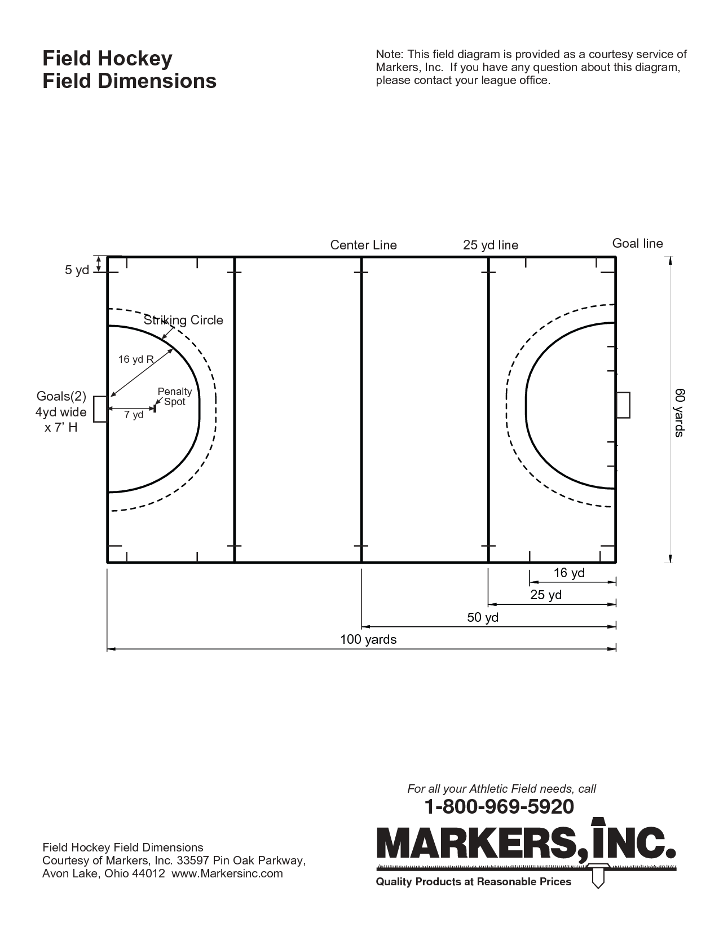

*Pitch Dimensions*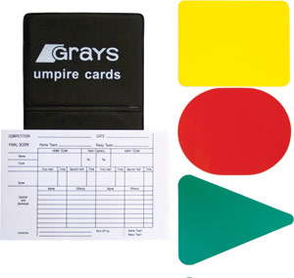

**Card System**

* Green card – Warning
* Yellow Card – Minimum of 5 minute sin bin. Can be longer, up to umpire
* Red Card – Off

**Terms**

* A foul outside the ‘D’ results in a ‘Free hit’.
* Inside the ‘D’ by a defender results in a ‘Penalty Corner’.
* A foul that prevents a goal results in a ‘Penalty Stroke’.

**Basic Field Hockey Rules**

* Players can only use the flat side and the inside edge of a hockey stick. Anything else is called ‘back stick’.
* The technical rule for the use of feet is: ‘If a player uses their feet to gain advantage, or the use of their feet affects play, it is a foul.’ All this means that if the ball hits a pupil’s foot and it doesn’t affect he game, it’s not really a foul.
* The hockey ball can be lifted in open play as long as it isn’t ‘dangerous’. Therefore if a pupil lifts the ball over a stick for example, that’s fine, but if flicked towards people, it is an offence.
* If any of these offences take place inside the ‘D’ by a defender, it is a ‘penalty corner’. However, like in football, if the offence prevents a clear goal, then it is a ‘penalty stroke’.
* If the offence is caused by an attacker in the ‘D’, then it is a ’16 yard hit out’ for the defenders. In this scenario, the defending team take the ball to the edge of the ‘D’ directly in line with the offence. It’s the same principle of a goal kick in football.

**Restarts**

* Side lines are the same as football. If team A knocks the ball off, team B take the side line ball.
* If an attacker knocks the ball over the end line, it is a ‘16’. The ball is brought to the edge of the ‘D’, directly in line with where it went out.
* If a defender or the keeper knocks the ball out, it is a long corner (At the corner of the pitch, 5m up the side line, there is a dash, that is the long corner mark).
* However, if the defender or keeper DELIBERATELY knocks the ball off the back line, it is a ‘penalty corner’.

**Remember**

* From ANY restart, other than a Penalty Corner, players can ‘self-pass’.
* If there is a ‘free hit’ to the attackers in the last quarter of the pitch, the ball has to move 5 metres before it can enter the ‘D’.